SQL Query Assignment – II

1. Find out the number of documentaries with deleted scenes.

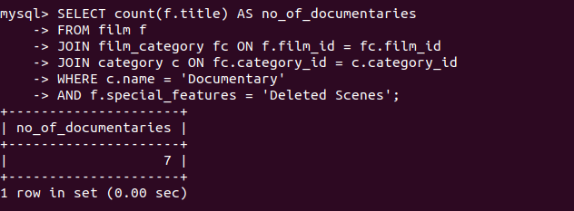

2. Find out the number of sci-fi movies rented by the store managed by Jon Stephens

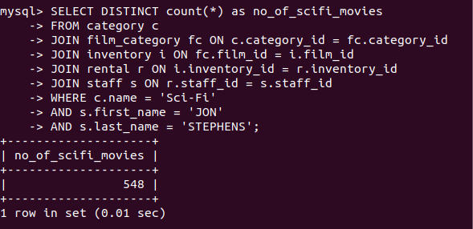

3. Find out the total sales from Animation movies.

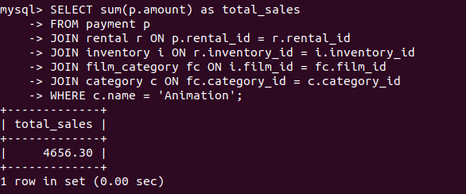

4. Find out the top 3 rented category of movies by “PATRICIA JOHNSON”.

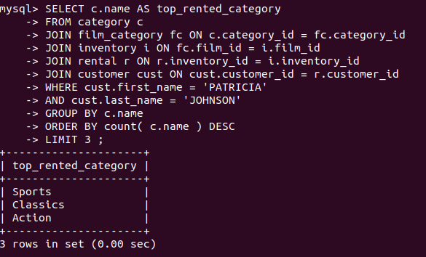

5. Find out the number of R rated movies rented by “SUSAN WILSON”

